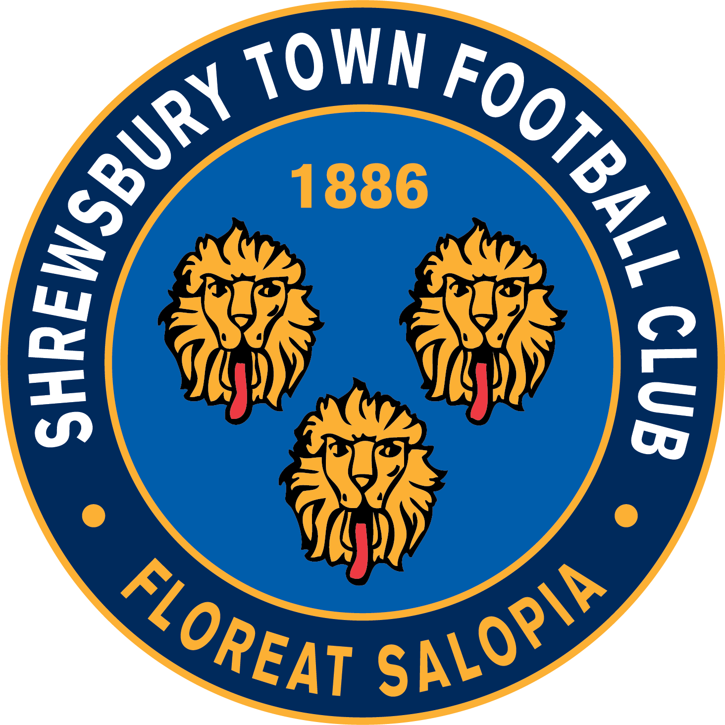
Job Description & Person Specification

Position Details
Position: Graphic Design & Media Executive | Department: Media | Reporting To: Head of Media
Overall Objective: To take the lead on the implementation of the Club’s visual output, working with both internal departments and external companies and to assist with the long term development of the Club’s visual strategy and content output across all of its digital channels as well as printed output across the club.

Job Description
Main Duties

- Take a leading role in the development of the Club's visual strategy
- Take a leading role to ensure the Club's visual output is fresh and up to date whilst keeping the club’s branding and identity clear and obvious at all times.
- Responsible for creating all online graphics, programme artwork, printed work and signage around the stadium.
- Take an active role in producing content for the Club’s social media and Club website in conjunction with the Club’s media team.

Key Tasks

- Create and develop graphics for all of the Club’s social media output.
- Create and develop artwork that will be used in and around the stadium
- Create and develop artwork and graphics for the scoreboard and matchday programme
- Assist with the development and implementation of the Club's content strategy.
- Work with the commercial department to ensure partner design & artwork is both valuable to the client and appropriate for the Club.
- Assist with ensuring the Club’s branding is kept throughout all departments, such as but not limited to our Academy, Women’s Team and Shrewsbury Town in the Community.
- Assist with the day to day running and supervision of the media team
- Ad-hoc duties.

Must Include

- The Employee must at all times carry out his/her responsibilities with due regard to the Club values and policies and procedures, in particular Health & Safety, Equality and Diversity, Confidentiality and with regard to the Data Protection Act.

The above Job Description is not intended to be exhaustive, the duties and responsibilities may therefore vary over time according to the changing needs of the Club.

Person Specification

Essential

Demonstrates honesty, integrity, reliability and the ability to ensure confidentiality at all times.

Friendly, well organized with the ability to multi-task and perform well under pressure.

Possess strong time management skills and have a flexible approach to work.

Communication: Able to communicate to the highest level, listens, interprets and conveys information in a clear and accurate manner, provides timely delivery of information and selects the most appropriate method of communication.
- Teamwork: Works within a team environment, co-operates with others, considers the needs of others and helps others to achieve objectives.
- Taking ownership: Ability to work autonomously on own initiative, pro-active in managing one’s own time, building an understanding of the internal and external environment in order to deliver work in a highly effective and professional manner.
- Resilience and the ability to maintain professionalism and a calm demeanor at all times.
- Excellent IT and Adobe skills
- Able to work to tight deadlines.
- To adhere and communicate the Club’s brand values to stakeholders whenever the opportunity arises.
- A commitment to continuing professional development.
- Experience of using Social Networking on behalf of a business/club, including Facebook, Instagram, Twitter, YouTube and TikTok.
- Experience of liaising with key partners, as well as internal departments.

Desirable

- Degree related in Graphic Design
- Motion Graphic skills
- Videography and Photography skills
- Ability to travel across multiple sites.
- Flexibility approach to long distance work based travel.
- Match day work including weeknights and weekends.

Role Requirements
- To ensure that the Club’s Safe-guarding and Vulnerable Adults policies and procedures are adhered to at all times.
- To adhere and communicate the Club’s brand values to stakeholders whenever the opportunity arises.

Shrewsbury Town Football Club is an equal opportunities employer and is committed to provide equality and fairness for all employees. Shrewsbury Town Football Club opposes all forms of unlawful and unfair discrimination.

Employee Signature Date .

Manager Signature Date .

