Review of the financial statements of Shrewsbury Town Football Club Limited for the year ended 30 June 2022
The review below has been performed with the goal of making the content of the most recently available set of accounts for Shrewsbury Town Football Club Limited understandable for all Salop fans – whether you have any sort of an accounting background or whether the words 'profit and loss' mean nothing to you whatsoever!
The key things to remember before you start reading:
- These accounts cover the year from 1st July 2021 to 30th June 2022 i.e., the 2021/22 season, where STFC competed in League One.

- This season saw some normality return with Covid restrictions being lifted, after they significantly impacted the 19/20 and 20/21 seasons.

- The period since 30th June 2022 is not covered as part of this review, as no financial information for this period is publicly available yet.

- These accounts will be publicly available via the Companies House website.

- I have not made any assumptions, judgements or estimates unless explicitly stated. This is important because it means that anyone else could reach the same conclusions as I have from reading these accounts.

- This is not an exhaustive review, but I have highlighted the key points from the accounts.

- These accounts are audited by Shrewsbury based accountancy firm WR Partners. An audit is a check on the accounts to make sure they are free from 'material' error i.e. that they do not contain any significant errors which would change the views of those reading them.
Summary
If you don't want to read all of the detail below the headlines are as follows.
- The club made a pre-tax loss in the year of £0.2m (20/21 season - £1.5m loss). The £1.2m decrease in loss is due to:

  - An increase in turnover of £2.1m
  - Offset by an increase in costs of £0.7m and a decrease in other operating income of £0.2m

- The club continues to have no debt and held £1.6m cash in the bank at 30 June 2022 (June 2021 – £2.3m).
- The directors did not take a salary or dividend payments from the club consistent with prior years.

- The club was in a positive net assets position at 30th June 2021 of £14.7m – that is to say it had £14.7m more assets than liabilities at that date (June 2021 - £15.1m).
If anyone has any questions/ comments please feel free to drop me an e-mail to ant.d.thomas83@gmail.com
The “Profit and Loss ("P&L") Account” or “Statement of Comprehensive Income”
This is the first key financial statement shown in the accounts.
The profit and loss account shows the "financial performance" of a company – that is:
- The revenue/ income the club has earnt in the year e.g., ticket sales, player sales, prize money less;
- The costs it has incurred in the same period.
Where the income is higher than the costs, this is called a profit. Where the opposite is true this is called a loss.
Note that an increase in profit of say £100 does not mean the same thing as an increase in cash of £100. This is because of the way accountancy works and some costs do not have an impact on the cash you have in the bank (for an example of this – see the section on intangible fixed assets below).
Each element of this statement is discussed below.
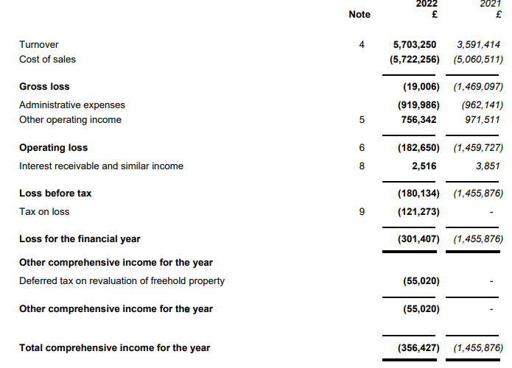

Turnover: This is the income the club has earned in the year. For a football club this will relate to ticket sales, merchandise sales, prize money, TV money etc. This is sometimes called “revenue” or “sales”.
The club provide a breakdown of turnover in the accounts:
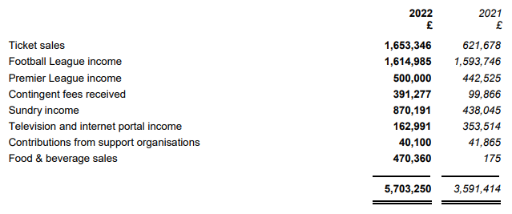
The most significant turnover streams for the club are ticket sales, income from the football league and sundry income (no further details are given on this last item).
In the 2021/22 season turnover increased by £2.1m – the main reasons being:
- Ticket sales increasing by £1.0m – mainly due to the lifting of Covid-19 restrictions
- Increase in food & drink sales by £0.5m – also linked to the above
Other operating income: In the year this totalled £0.8m – a £0.2m reduction on the previous season – this relates to Government Grants (e.g. Covid Furlough scheme) and insurances receivable.
Cost of sales: This is the first cost we see in the P&L account and it is the cost required to deliver the services provided for a company. For example – for a company that sells cars, their turnover is the amount received per car, and the cost of sale is the cost to manufacture that car and any other costs needed to be able to sell that car. For a football club the key cost of sale is salaries. These are likely to be split between cost of sales for players’ salaries and other costs associated with putting on matches etc.
For a football club, salaries are split between Cost of Sales (salaries linked directly to revenue, such as player salaries) and Administrative Expenses (sales/ wages which are fixed, such as employees of the club working in administrative or other roles).
The accounts give details of the total amount spent on salaries/ wages – this covers all club staff including players. The amount spent on salaries in the 2021/22 season was £4.4m, c. £0.3m higher than in the prior season.
Administrative expenses: These are other costs of the club and are likely to include utilities (such as water, electricity etc.) and repairs/ maintenance needed on the stadium. These costs have fallen marginally year on year.
Other things to note: The club made no salary or dividend payments to directors or the chairman, consistent with the prior year. Such payments must be stated in the club accounts had they been made.

The “Balance Sheet” or “Statement of Financial Position”
This shows the "financial position" of a company and is shown for the year-end date only – in this case 30th June 2022. It shows how many "assets" a company has, and how many "liabilities" – the difference between these two figures is called the “net assets”. The balance sheet also shows a company’s “capital and reserves” – this is the amount that has been paid for the shares in the company and the historical profits/ losses made by the company since it was formed.
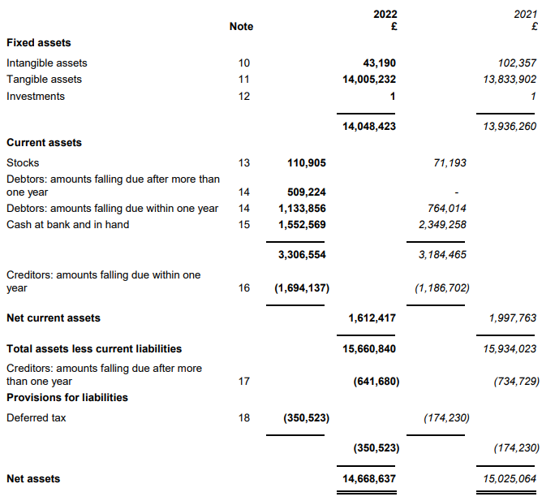

Assets
An asset is a resource owned by a company which has some economic benefit to the company – either short term or longer-term. Each sub-category is discussed below. The most obvious asset for any business is cash – the “economic benefit” being that it can be used to buy other assets, or pay bills etc.
Fixed assets - tangible
These are assets that are used by the company to generate economic benefit/ are used in the running of the business. Tangible means they physically exist. For STFC these mostly relate to the stadium. The balance has increased marginally by £0.2m in the year.
Fixed assets – intangible
Intangible assets are ones that cannot be physically held like a tangible asset can. For some businesses this may mean an online platform/ website which will result in revenue for the business going forward.
For football clubs these primarily relate to players' contracts when a transfer fee is paid. This “asset” is then reduced each year of the contract. This reduction is called "amortisation" in accounting terms and is recorded as an expense to the business and so is included in the P&L account. The balance may also be “impaired” if there is a reason to believe the asset no longer holds value. For example, if a player suffered a career ending injury.
The intangibles balance has decreased by less than £0.1m. This has been driven by additions of £80k, offset by net disposals (sales) of £50k, and amortisation of £90k.
It is worth noting that transfer fees agreed after 30 June 2022 (i.e., pre-season for the 2022/23 season would not be included in this set of accounts).
Current assets
These are called "current" because they are easier/ quicker to turn into cash than fixed assets (generally within twelve months). Each sub-section is discussed below.
Stocks
Stocks are either club-shop merchandise or items used by the club in its day to day running (e.g., food). The balance has not moved significantly.

Debtors
These are amounts owed to a company by other companies or individual. For a football club they can relate to amounts owed by other football clubs (e.g., for transfer fees), from other organisations (e.g., the FA) or "prepayments" – this is where a company pays for a future service in advance. For example, if you paid for the whole of next year's car insurance now for £300, you would have a £300 prepayment – as that is not a cost that relates to your current year hence doesn't impact the P&L for this year.
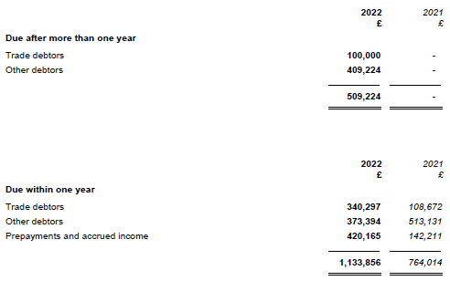

Trade and other debtors have increased in total by £0.6m to £1.2m – suggesting the club are owed money, potentially for player sales, which can be expected to be received in the future.
You may notice that debtors are either shown as “due within one year” or “due after more than one year” – this means when the cash is contractually due to the club. When, for example, a player sale is made, the buying and selling clubs may agree that the transfer fee is paid over a period of years, rather than immediately.
Cash
This is just what is sounds like – what is in the club's bank account. Ever heard of the expression “cash is king”? It is because without it a business can’t operate – because it wouldn’t be able to pay its staff or suppliers. For a football club who is so reliant on its staff, it is therefore vital to ensure you have a means to pay salaries and other costs.
The cash balance has decreased from £2.3m to £1.6m. The club includes a “cash flow statement” in its accounts which gives the main reasons for movements in its cash balances. Fans may note that included in this statement is that the club received £300k in respect of player sales (intangible assets) in the year and spent £245k on acquiring player contracts.
Liabilities
A liability is an amount owed by a company which will lead to the outflow of economic benefits – for example, a payment in cash for a debt owed – either in the short term (in the next twelve months) or long-term. Each sub-category is discussed below.
Current liabilities
This description is given to amounts the club owes to individuals or other clubs/ organisations. They are called "current" because they are repayable in less than 12 months. The key items for STFC are:
- Payments received on account (largely season tickets paid for in advance): When you buy a season ticket for next season, and pay for it in advance, the club cannot recognise it as "turnover" until the season in which it relates to. So advanced season ticket sales for the 22/23 season are not included in the turnover figure in the P&L. Instead, they are shown as a current liability. Why? Because theoretically the club have not provided the service to the customer yet (giving them access to the matches) and the customer could ask for their money back if they changed their mind.

- Trade creditors: Amounts owed relating to the day-to-day business – this could be transfer fees, payments to suppliers to the club etc. The balance increased by c. £0.3m year on year – given the increase in general trading activity post the lifting of Covid-19 restrictions, this movement is not unexpected.

- Other current liabilities (taxation and social security, other creditors, accruals, and deferred income): This relates to items such as payroll tax, one-off bills or where invoices have not yet been received by the club. The term "accrual" is used in the accounts. This is the opposite to a "prepayment" and it means a company have used a service but not paid for it yet. A good example would be if you pay £20 a month for broadband but pay for the current month's usage next month. This would lead to an accrual in the balance sheet of £20.

Capital and reserves
This shows:
- The only change in the year is the loss for the year after tax of £0.3m.
- The P&L reserve stands at £11.5m – this is the total cumulative profits the club has recorded since it was founded as a company.
- Share capital has remained stable at £2.5m whilst the movement in the revaluation reserve is minimal.
- This means total equity stands at £14.7m. This is equal to the amount the club’s assets are higher than its liabilities.

