How to buy Away Tickets online.
- Log in to your online account. For help in activating your online account Click Here.

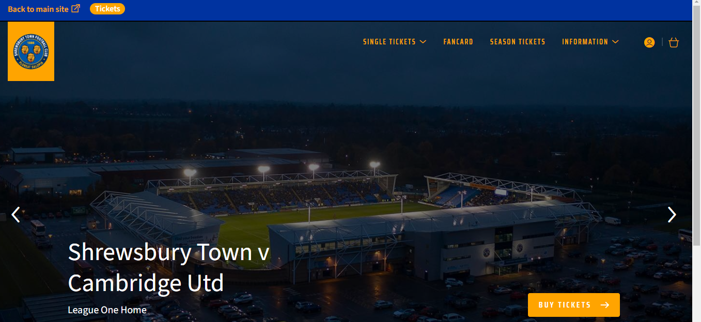

- Click ‘Single Tickets’ and then ‘All Matches’ to bring up the game list.

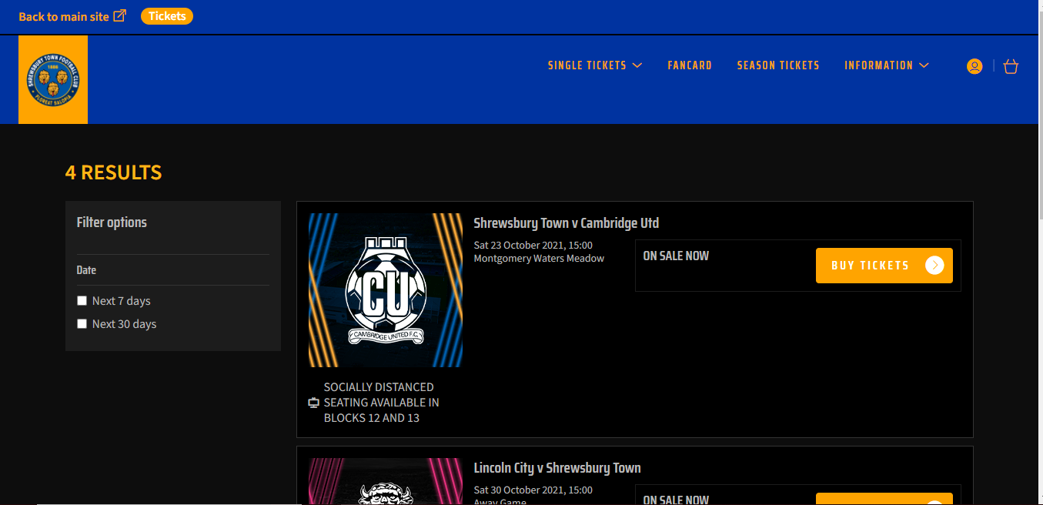

- Choose your away game and ‘Buy Tickets’

- Pick the quantity of tickets required and click on area required at bottom of the screen on left.
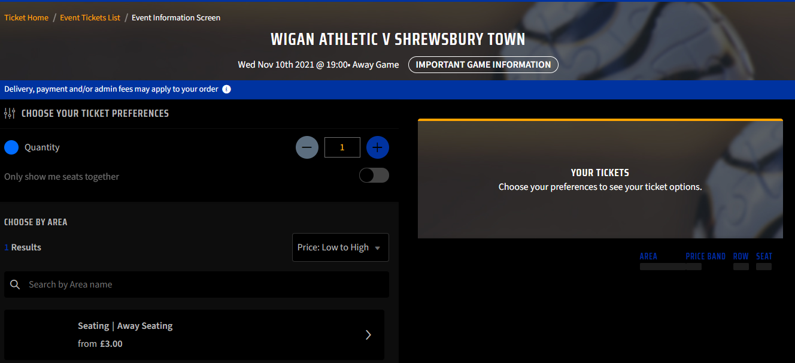

- This opens up the ticket price class window.
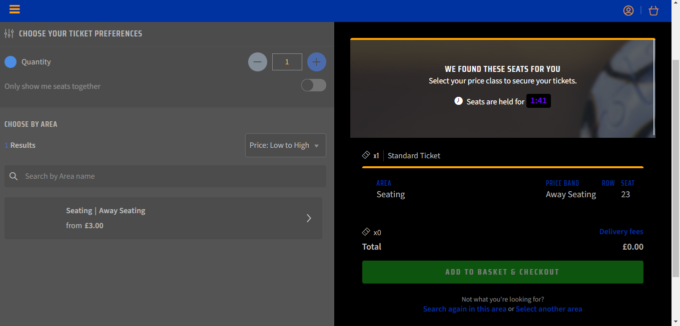

- Choose the age category for your ticket first, as you are the Lead Customer.
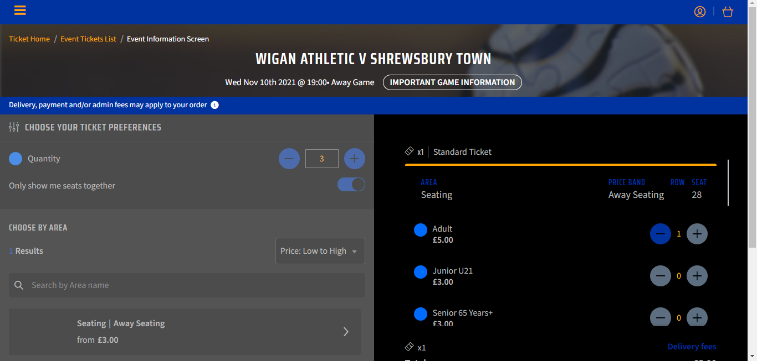

- Then scroll down within the ticket window to find the next ticket. The same price class options will be listed.
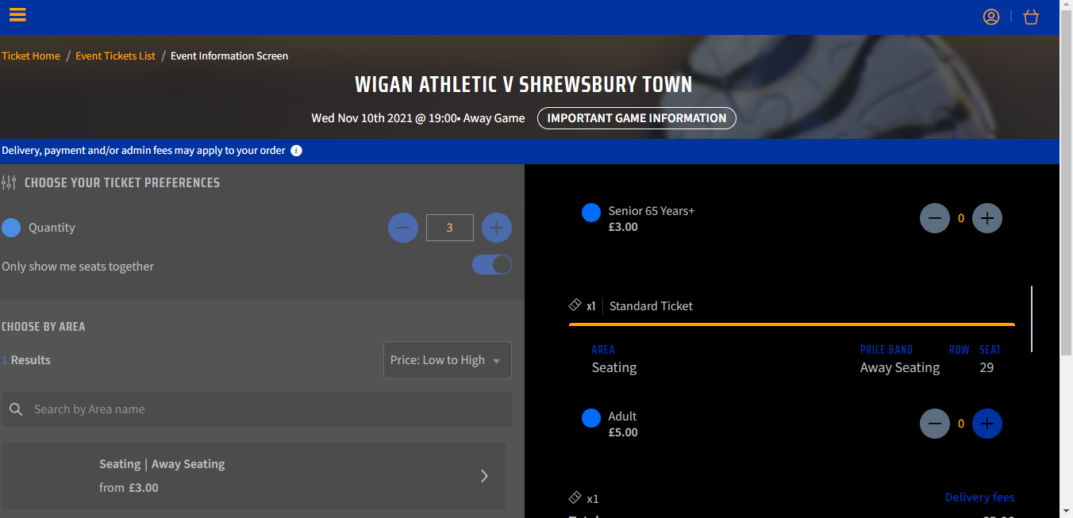

- Once one price class has been selected for each ticket in the list, at the bottom of the ticket window, the little ticket icon should show the amount of tickets you want to purchase.

- Click add to basket and checkout. Check ticket details and price classes are correct. At this point you need to ‘Reassign’ each ticket to individual supporter numbers if you have them so that they receive loyalty points for the game. Once done ‘Proceed to Checkout’.

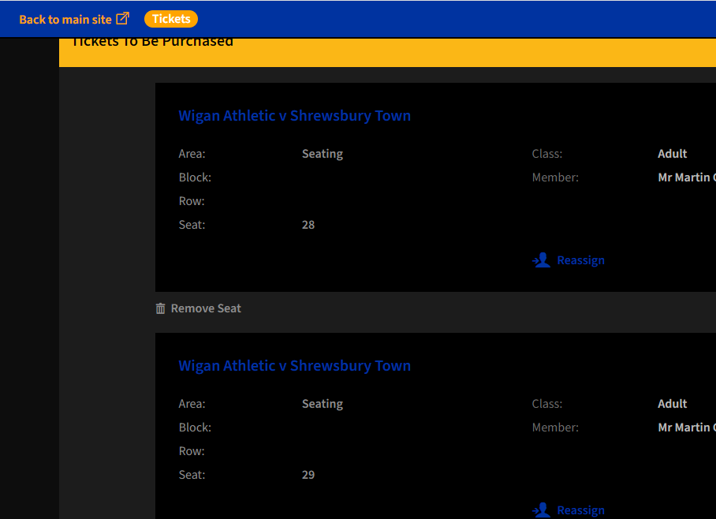

- Input card details if not saved and then in the Delivery Options choose either Collection or Postage option. Any tickets chosen as ‘Collection’, if not collected from the STFC Ticket Office will be sent to the Away Club on Match Day for collection from there.

- Review your order and ‘Complete Purchase’.

- You will be sent a Confirmation email. This is not a match ticket.

Any questions regarding the process, please drop us an email on tickets@shrewsburytown.co.uk or call us on 01743 273943.

