How to buy Digital Tickets Online.
- Log in to your online account. For help in activating your online account Click Here.

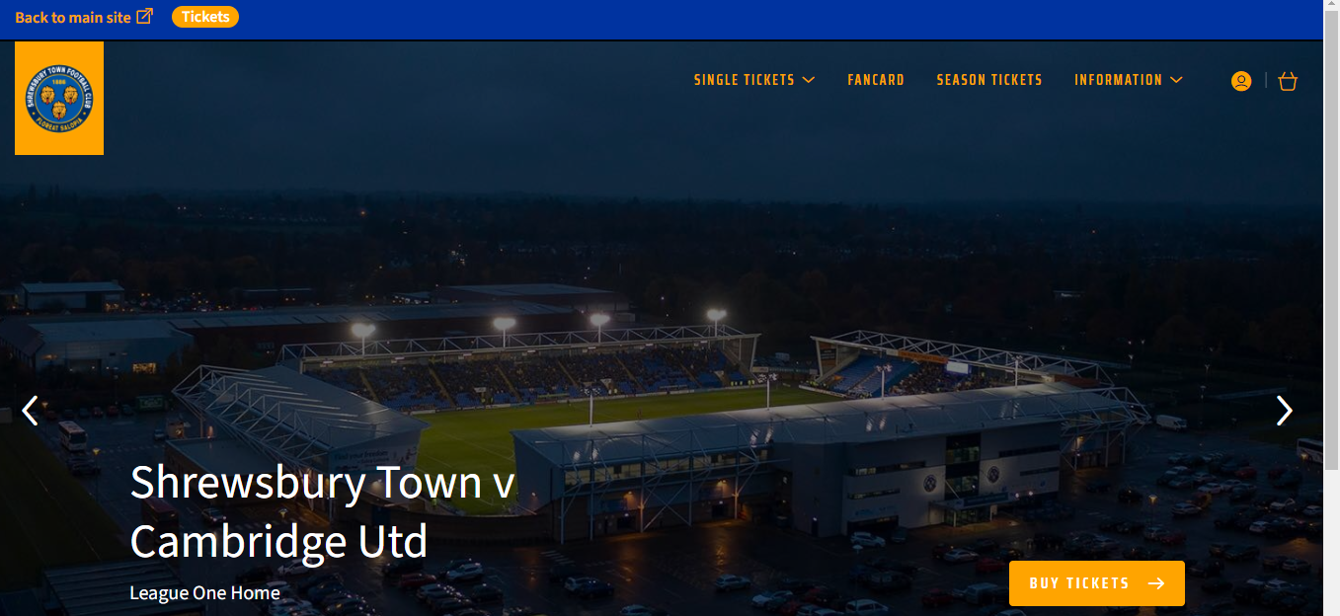

- Click ‘Single Tickets’ and then ‘All Matches’ to bring up the game list.

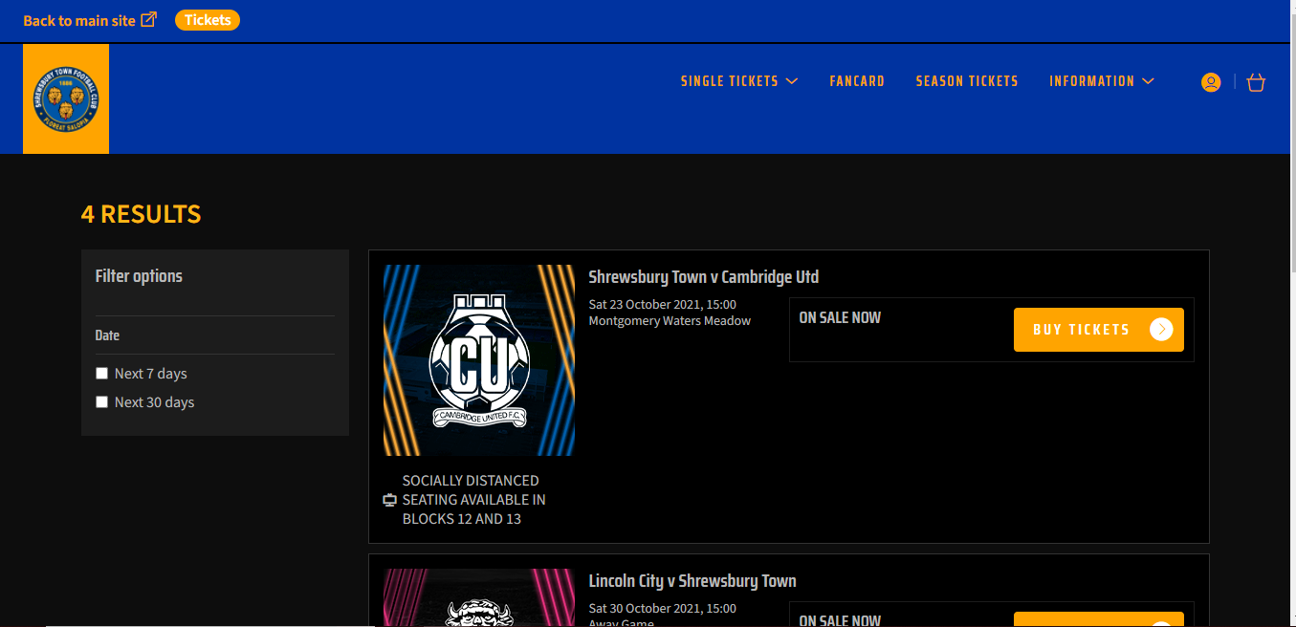

- Choose your game and ‘Buy Tickets’

- Pick the block you want to sit in.

- Click on the first seat you want to buy and choose the relevant price class. Repeat this process for all seats.

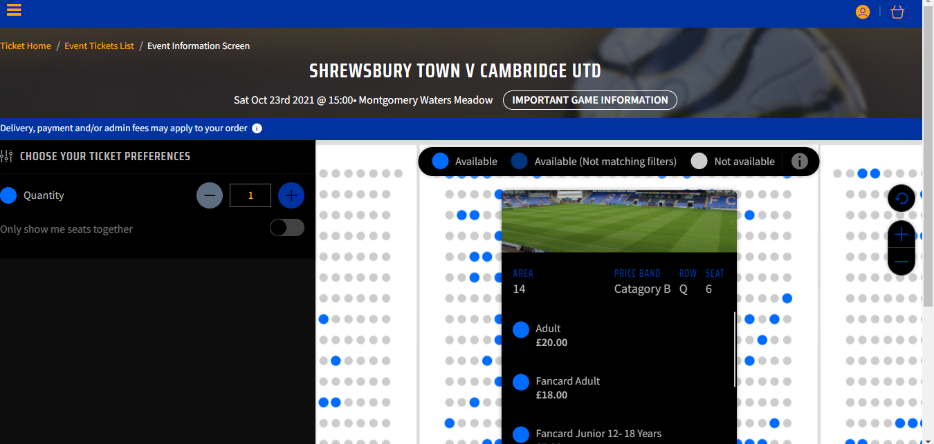

- Click on your basket at the top right of the screen. Check ticket details and price classes are correct. At this point you need to ‘Reassign’ each ticket to individual supporter numbers if you have them so that they receive loyalty points for the game and can have the ticket added to a FanCard if required. Once done ‘Proceed to Checkout’.

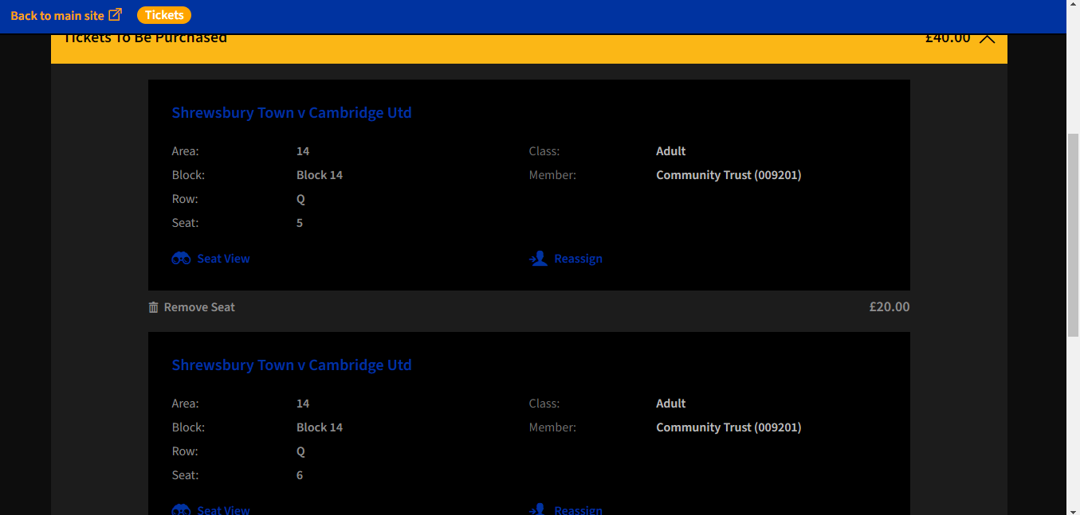

- Input card details if not saved and then in the Delivery Options choose ‘Digital Ticket/Print at Home’.

- Review your order and ‘Complete Purchase’.

- You will be sent a Confirmation email. This is not a match ticket.

- You will then be sent an email with your tickets on. This will have a PDF for each ticket which needs printing out or you can add the tickets to your Apple Wallet or Google Pay by clicking on the icons.

- Your printed ticket (if selected) will look like this:-

- If you add to Google Wallet/Apple Pay you will see a screen that looks something like this.

- Once added to the app and opened up, your match ticket will look like this.

